An informal letter
friendly
first name

Greeting
Hi Amira

How are you? During the holidays I went to London with my dad and we saw some amazing things!!!!!

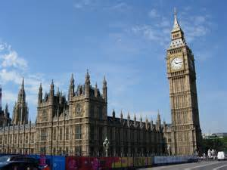
First we went to Big Ben. Lots of people think Big Ben is a clock but really it’s a bell. Suddenly it started chiming!
pictures
paragraphs

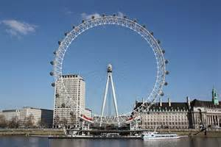
After that we went to the London Eye. We went high up into the sky and my dad was scared haha. I could see all over London. It was very exciting.

Finally we walked along the Thames to the London Aquarium.
The fish were amazing and we even saw a shark…ooooh!
ending
See you later.
Katie xxx
first name
